Pike County Middle School
Supply Lists

Students will not be issued lockers during Covid-19 restrictions – students may use book-bags to carry supplies and materials to classes. Please plan to keep a year-long supply of notebook paper, pencils, and pens at home. Plan a time each week for your student to restock necessary items at home.

Connection classes change every nine weeks during the school year (exceptions: Band/Chorus). Those classes may request an additional folder or notebook as needed. The 3-prong folder should be standard for most of the connections.

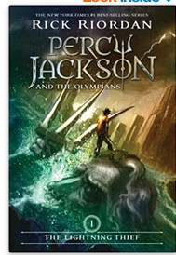
6th Grade Academic Supply List
Quantity | Description
1 | 2 inch 3 ring binder
2 | 1 inch 3 ring binder
1 | Spiral notebook – 1 subject (70 Pages)
1 | Package of 5 dividers with pockets
1 | Basic 4 function calculator – available for purchase in Media Center
1 | Threaded Marbled Composition Book
1 | Three Prong Pocket Folder (for connections classes)
1 | Year supply of notebook paper (leave extra at home)
1 | Package of Post-It Notes
1 | Pencil Pouch (including):
 | Pencils
 | Blue or Black Pens
 | Colored Pencils (8 pack)
 | 4 Highlighters (different colors)
 | Erasers
1 | Personal copy of these books for ELA:
 | The Lightning Thief: Percy Jackson and the Olympians (Book 1) By Rick Riordan
 | The Boy who Harnessed the Wind By William Kamkwamba

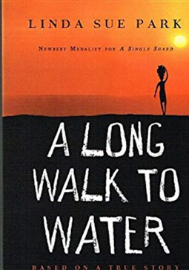
7th Grade Academic Supply List
Quantity | Description
2 | 2 inch 3 ring binder
1 | Spiral notebook – 1 subject (70 Pages)
1 | Package of 5 dividers with pockets
1 | TI-30XS Multiview Calculator – Available to purchase in Media Ctr ($20.00)
1 | Threaded Marbled Composition Book
1 | Three Prong Pocket Folder (for connections classes)
1 | Year supply of notebook paper (leave extra at home)
1 | Package of Post-It Notes
1 | Pencil Pouch (including):
 | Pencils
 | Blue or Black Pens
 | Colored Pencils (8 pack)
 | 4 Highlighters (different colors)
 | Erasers
1 | Personal copy of these books for ELA:
 | A Long Walk to Water By Linda Sue Park
 | Patient Zero By Marilee Peters

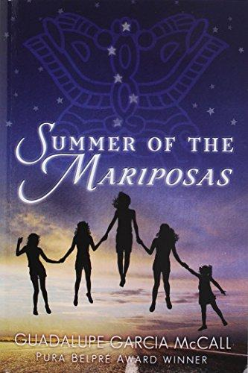
8th Grade Academic Supply List
Quantity | Description
2 | 2 inch 3 ring binder
1 | Spiral notebook – 1 subject (70 Pages)
1 | Package of 5 dividers with pockets
1 | TI-30XS Multiview Calculator – Available to purchase in Media Ctr ($20.00)
1 | Threaded Marbled Composition Book
1 | Three Prong Pocket Folder (for connections classes)
1 | Year supply of notebook paper (leave extra at home)
1 | Package of Post-It Notes
1 | Pencil Pouch (including):
 | Pencils
 | Blue or Black Pens
 | Colored Pencils (8 pack)
 | 4 Highlighters (different colors)
 | Erasers
1 | Personal copy of these books for ELA:
 | Summer of the Mariposas By Guadalupe Garcia McCall
 | Omnivore’s Dilemma By Michael Pollan

